**1. Introduction**

At present, mobile devices can perform multiple functions ranging from a basic communicating device to those of a personal computer. Over the years, mobile devices turned from analog to digital and has produced array of data services. Mobile devices growth has increased rapidly in the last ten years. Mobile devices are becoming the central part of computing in day-to-day life [5]. Technological improvements have made exceptional changes in the mobile device design in terms of memory, processor speed, size and number of cores.

The rest of the paper is organized as follows. Section 2, contains details about the mobile device characteristics. Section 3, provides a discussion about the change in memory considerations in mobile devices with the growth in technological advancements. Section 4, describes the increase in processor speed in the last 10 years. In section 5, information about the change in size of mobile devices throughout the years is reviewed. Section 6 gives the change in size of the mobile devices. In section 7, simple conclusion is discussed.

**2. Mobile Device Characteristics**

Mobile devices can be differentiated by their physical and technical characteristics (e.g., memory, size, processor speed). Mobile devises can be broadly categorized into feature phones and smartphones. Feature phones provide basic voice and texting communication, whereas smartphones offer improved capabilities and services for multimedia.

Smartphones add better potential for running collection of general and exceptional applications. Smartphones are better than feature phones because they have touch screens and support higher resolutions. Table 1 shows the hardware characteristics of feature phones and smartphones.

Table 1. Hardware characterization.

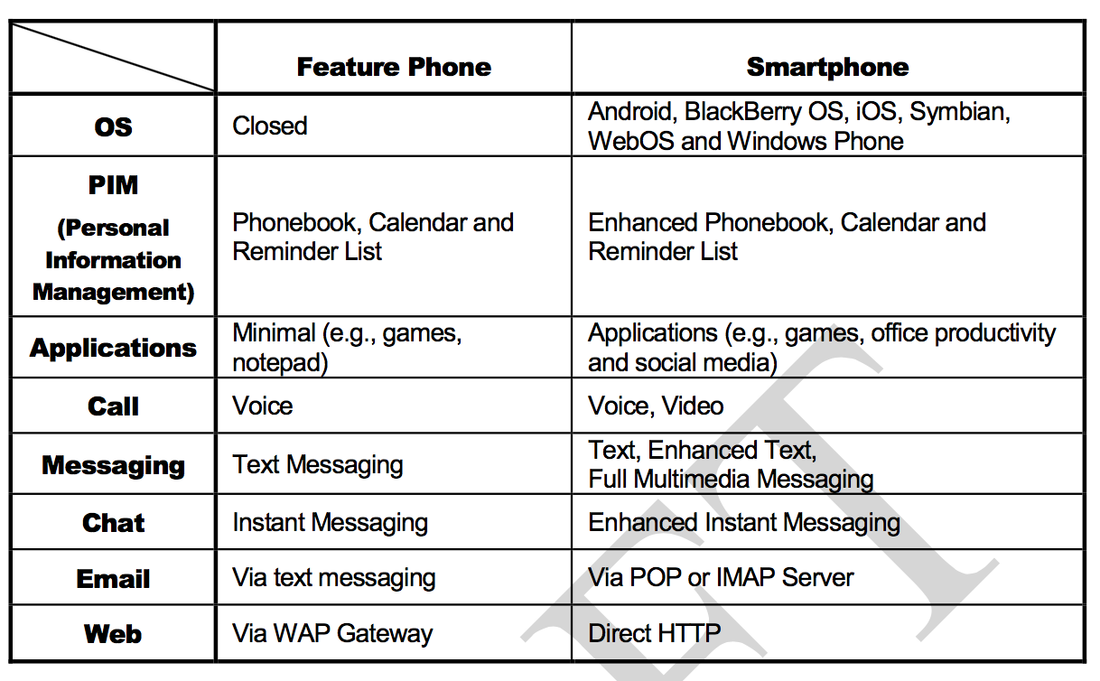

. Table 2 highlights the dissimilarities in software capabilities of feature phones and smartphones.

Table 2. Software characterization.

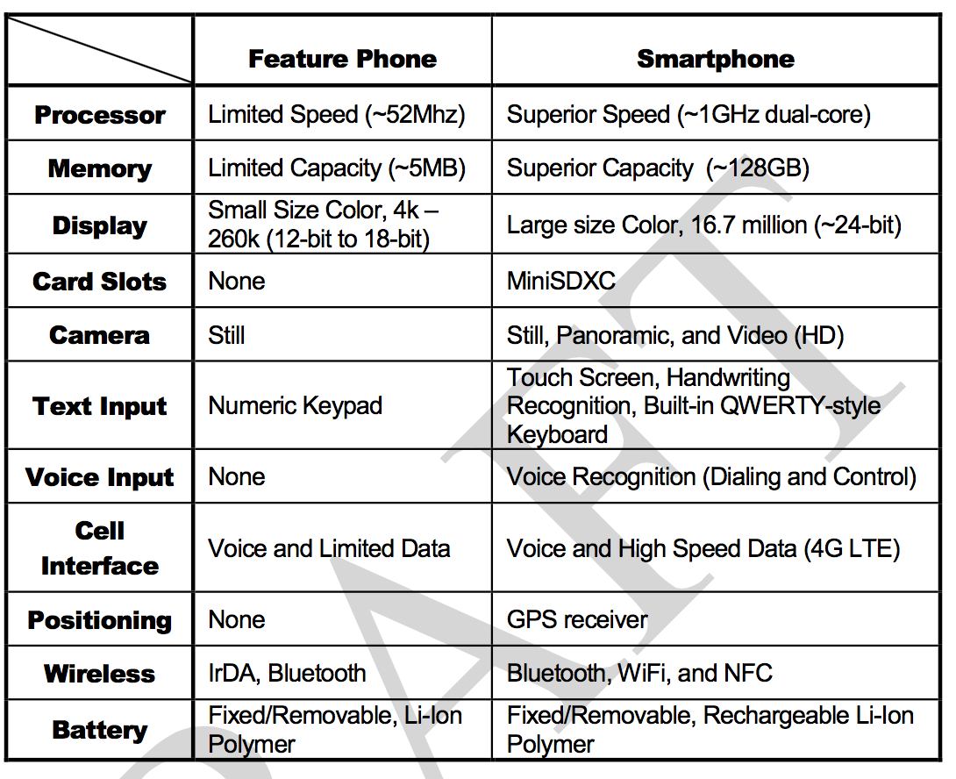

**3. Memory Considerations**

Mobile devices are made of both volatile and non-volatile memory [2]. Volatile memory is referred as RAM (Random Access Memory) and is used for temporary storage of data. The data stored is lost once the power is turned off in mobile device. RAM is volatile in nature, since it is used only for program execution in mobile devices. Present generation mobile device manufacturers are moving from SRAM (Static Random Access Memory) to DRAM (Dynamic Random Access Memory). Non-volatile memory also referred as flash memory is used for permanent storage of data. The contents are not damaged by power loss or turning off mobile device.

Flash memory has become a strong and cost-effective solid-state storage technology universally used in mobile devices. Mobile devices comprise two types of flash memory namely NAND and NOR. NAND flash memory, designed as a tiny cell, is primarily used as a high-density data storage medium for mobile devices, whereas NOR flash memory is used for code storage and execution in mobile devices. Recent mobile devices support NAND as an alternative to or an addition for NOR flash to build a collection of applications. Performance requirements and data storage capabilities in mobile devices have increased with increase in usage of feature-rich phones that includes video, camera, music, gaming and other functionality. NAND has become an attractive alternative in non-volatile flash memory of today’s mobile devices [2]. The reason behind this is higher speed write and erase performance and lower cost per megabyte [2]. As a result, recent mobile device memory subsystems are using NAND in some traditional NOR-based applications. Recent mobile devices support memory cards apart from in-built NAND flash memory to increase memory capacity [2]. Figure 1 highlights the different memory configurations used in all mobile devices.

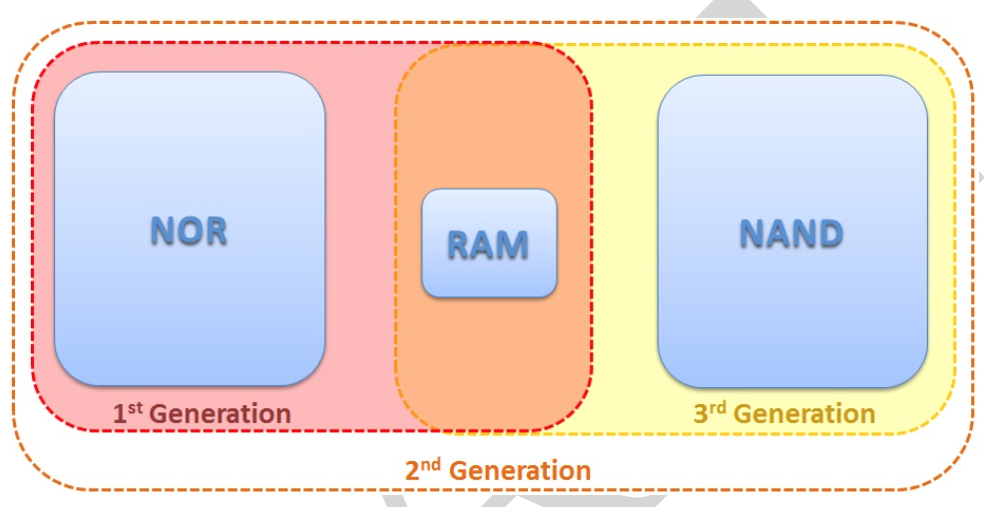

Figure 1. Memory configurations.

**4. Processor Architecture**

The introduction of new architectures and steady growth in semiconductors integrated circuits resulted in a glorious improvement of performance [1]. Computational power in processors has increased beyond 50% in the last 15 years. Traditional microprocessors are used to run at KHz clock frequencies, whereas present microprocessors, which are made of tens of millions of transistors, can run at GHz clock frequencies [1].

Digital Signal Processor (DSP) is a particular microprocessor used in mobile devices. Traditional DSP architecture uses Harvard architecture, which requires separate instruction memory and data memory to run instructions [3]. In modern DSP architectures, progress in chip creation has resulted in a greater increase of computational power. Traditional DSP is used to provide 5 GIPS (Giga Instructions Per Second) during 2000 and by the year 2010 it has increased to 50 GIPS [3].

System on Chip (SoC) based architecture simplified the mobile device architecture with SoC designs. Highly integrated multicore technology in SoC emerged with better performance and low power designs. Most of the recent mobile devices are single or dual-core SoC’s.

ARM based processors are the most commonly used in smartphones. ARM processors are specially used in smartphones because of its better performance and low power usage. Different ARM architectures namely ARMv5, v6 and v7 used in smartphones. ARMv5 is used in low-end devices, whereas ARMv6, ARMv7 are used in modern high performance devices [3]. ARM is the major hardware architecture and used in Windows phone, IOS, Blackberry, Android, Windows RT, MeeGo, OS/Blackberry10, Firefox OS, Sailfish OS.

ARM Cortex and Snapdragon are the popular processors largely used in recent mobile devices. A single core ARM Cortex A8 processor with 1.4GHz was taken into the consideration till 2011. ARM processors clocked at 3GHZ were popular in the year 2014. Snapdragon is based on System on a chip processor produced by Qualcomm. Qualcomm Snapdragon 800 processor with 2.3 GHz dominated all other processors in the mobile industry in the year 2013. Figure 2 shows different mobile devices released in the year 2014 with their corresponding processors, clock speed and number of cores.

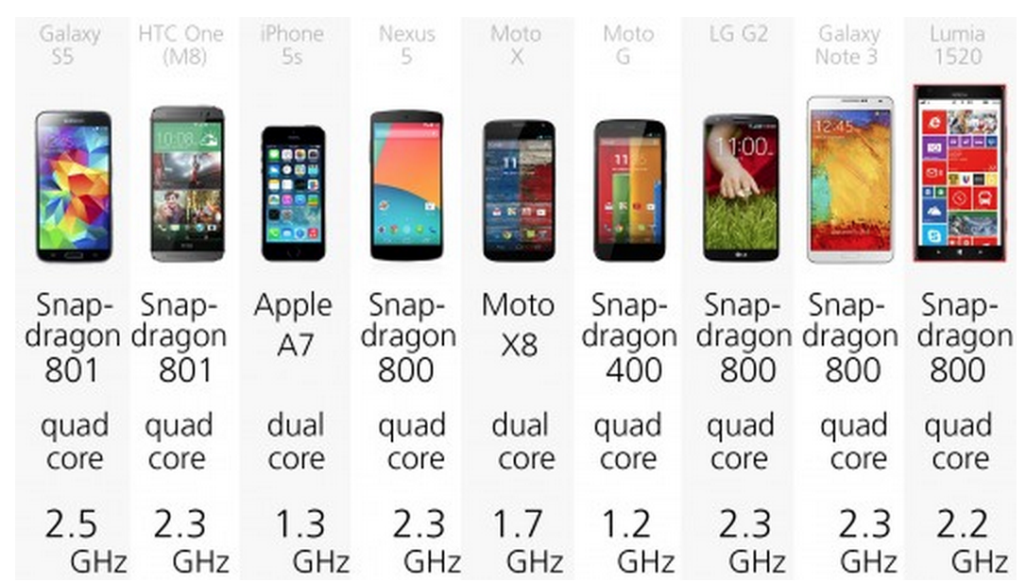

Figure 2. Mobile devices with their corresponding processors released in the year 2014.

**5. Change in size**

Along with the technological growth in mobile devices over the years, there was also increase in size of the mobile devices. Smartphones era started in the year 2007, when touchscreen phones with large display interface entered into the mobile world. These touchscreen mobiles completely replaced the button control and small visual screen interface, which existed previously.

The display size of the smartphones is increasing every year considering the increase in need for better resolution, gaming and web browsing. Some of the recent smartphones, named as phablets, has screen size ranging from 5.1 inches to 7 inches.

**6. Other improvements**

Modern mobile devices are integrated with a number of different sensors including an accelerometer, a compass, a gyroscope and a barometer, as well as other features, which includes GPS, Wi-Fi, and Bluetooth. An accelerometer and gyroscope work together in a mobile device to provide the directional movement of a device along with rotation. The digital compass works by using magnetometer, which measures earth’s magnetic field. As a result, mobile devices can act like a navigation system. The Barometer helps the GPS system inside a mobile by finding altitude data to provide a faster GPS signal. Graph 1 shows the increase in use of accelerometers in mobile devices from 2006 to 2010.

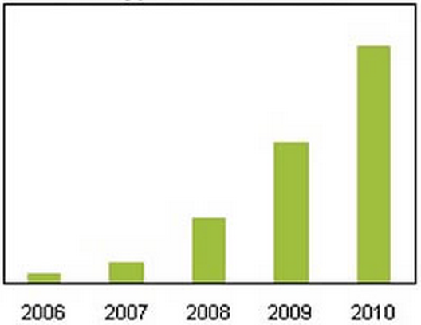

Graph 1. Growth in use of accelerometers in mobile devices from the year 2006 to 2010.

**7. Conclusion**

In conclusion, mobile device has become a major part of human’s day-to-day life. This paper presented significant information about the technological improvements in the mobile world during last 5- 10 years. Multimedia capabilities of mobile devices will continue to advance and increase in memory size has no barrier either. Most of the recent mobile device processors are ARM-based and System on Chip based architecture will improves the device performance in future mobiles. Size of the mobile devices is getting bigger every year, but at some point there should be a limit in mobile device size that will make it easier for people to carry their device with them.

**8.References**

[1] Farinaz Koushanfar, Vandana Prabhu, Miodrag Potkonjak and Jan M. Rabey, Processors for mobile applications.

[2] Jim Rasmusson, Fredrik Dahlgren, Harald Gustafsson and Tord Nilsson, Multimedia in mobile phones-The ongoing revolution.

[3] Mahendra pratap Singh and Manoj Kumar Jain, Evolution of processor architecture in mobile phones. International journal of computer applications (0975-8887), volume 90- no 4, march 2014.

[4] Margarita Esponda, Trends in hardware architecture for mobile devices.

[5] Nicholas D. Lane, Emiliano Miluzzo, Hong Lu, Daniel Peebles, Tanzeem Choudhury and Andrrew T. Campbell, A survey of mobile phone sensing.